Name: Zainab Rizwan

Roll no. 2019-CE-36

Due Date: 10th April

Submitted to: Ma’am Darakhshan

DBMS Lab10: Query Execution Plans

--1-Select categories with id less than 5

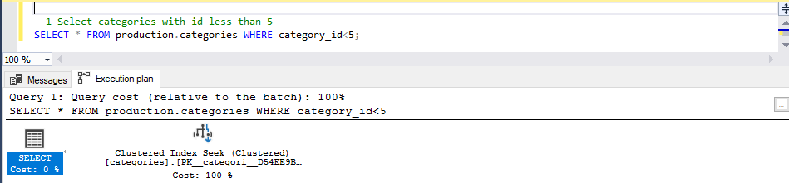

--2-View the first and last names of all customers--

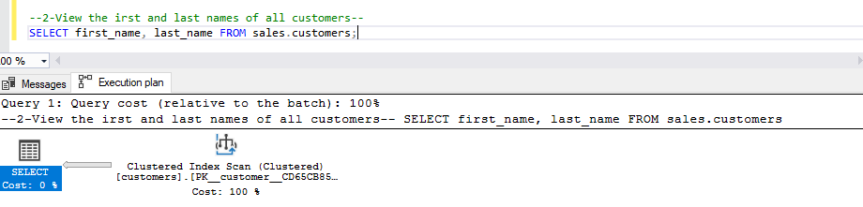

--3-Select production stocks quantity of store located in city 527

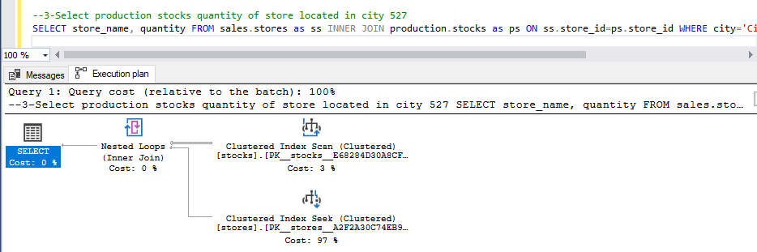

--4-Return the top 5 most cheapest products--

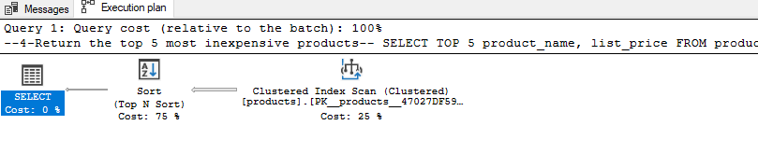

--5-Select products with the model year 2017 AND brand id 9

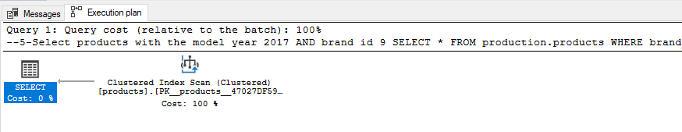

--6-Select most expensive product of each company

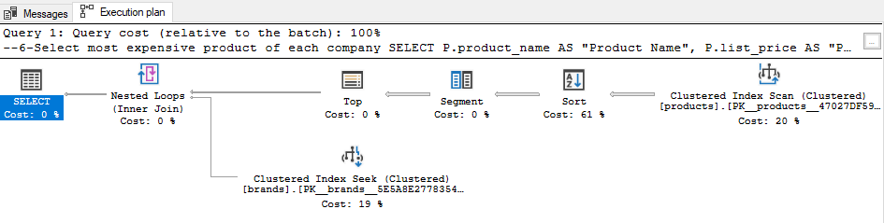

--7-Select customers with the same last name

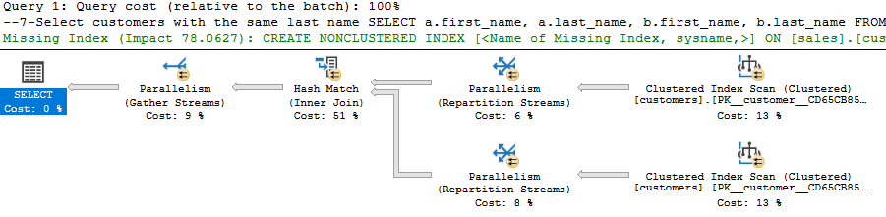

--8-Select staff which has less than 1 customer

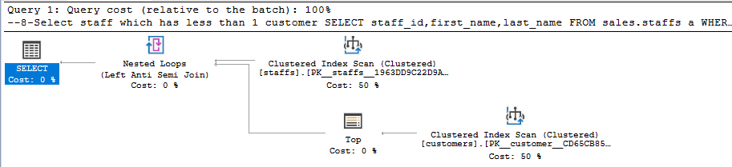

--9-Receive product information from products and categories table

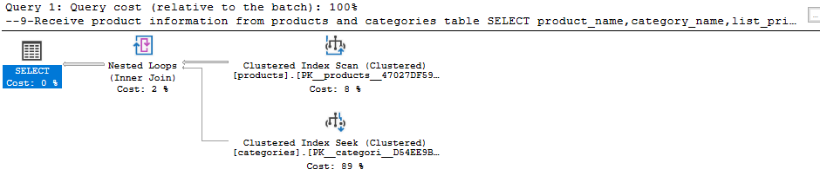

--10-This view gets products along with their brand names

